To install the EOHSI VPN client on your PC double click the icon to get started.
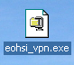

Follow the next few screens to complete the installation
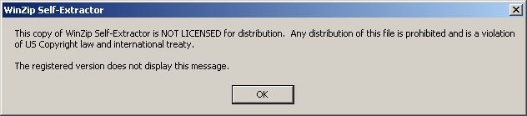

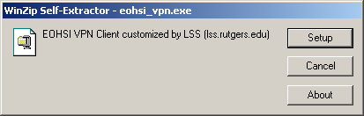
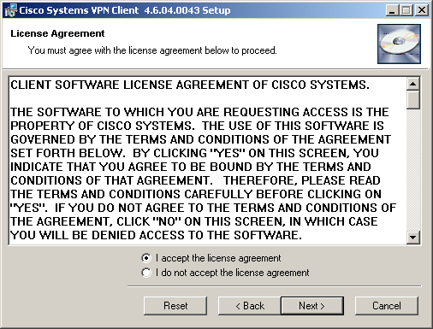
Click here & here to continue
Accept the license agreement and click Next
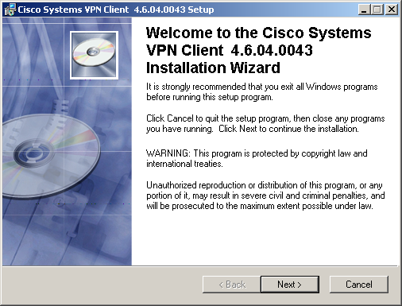
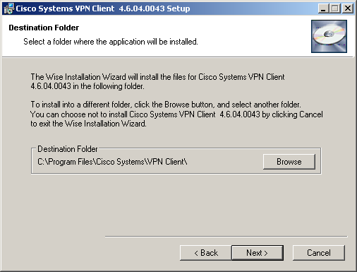
Click here to continue
Accept the default install location. Click next

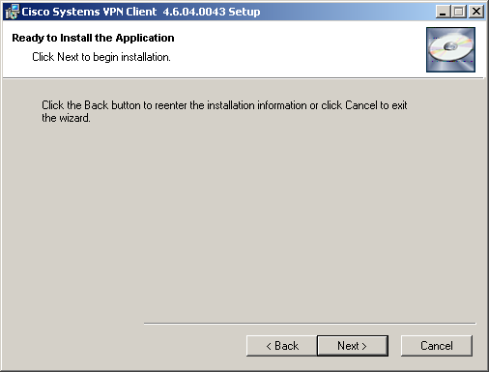

Click next to start the installation

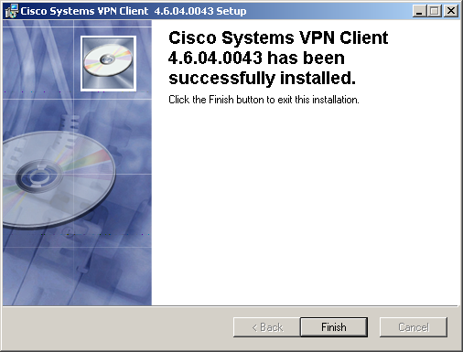
Once the installation (it will take a few minutes) successfully completes, click Finish and then restart your PC/Laptop.

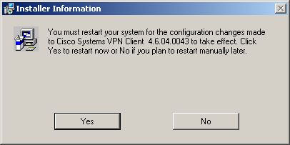

If you choose to, restart your PC/Laptop at this time by clicking on Yes. Once you do, your machine will shutdown automatically. Make sure you have any open work saved.

Once the installation is complete you can launch the VPN client from the Start Menu

Click on Start Button→All Programs→Cisco Systems VPN Client→VPN Client

The VPN Client Dialog box appears
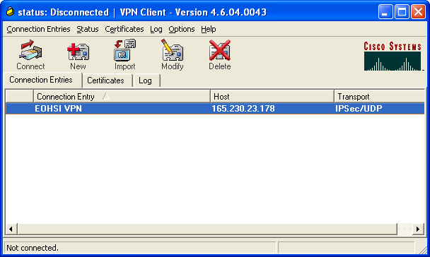
Highlight EOHSI VPN and Click Connect

After a few moments the Login Box appears. Enter you EOHSI network login information

Use the format: eohsi\<your login> for example eohsi\gkovach

Enter your password and click OK

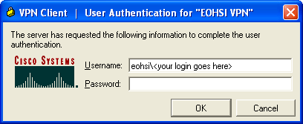
<enter your password here>

A connection is established when the VPN client screen disappears and a small gold lock appears in the lower right hand corner in the system tray.



When you wish to disconnect, right mouse click on this icon in the system tray and select Disconnect.

Mapping your Network Drives with the VPN Connection

Once you are connected to EOHSI via the VPN connection, you can now connect to your file shares. To do this:

- Click on the Start button and then select Run
- In the Open: box, type \\File\ then hit Enter
- A screen appears listing the available shares

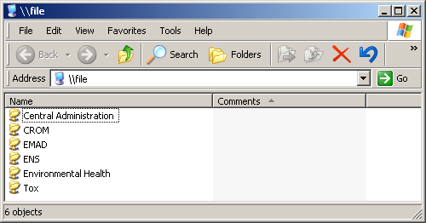

- Highlight the share you wish to map (or navigate to the specific directory) and right mouse click on it and select Map Network Drive…
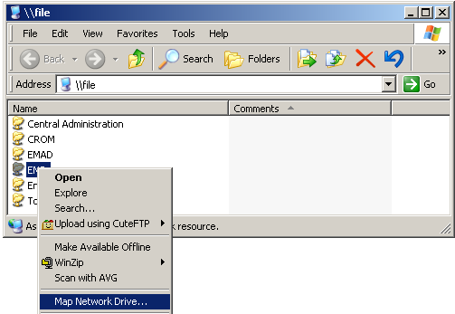

- A Map Network Drive Dialog box appears.
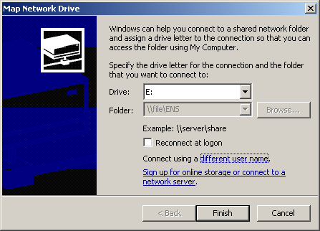

Select a Letter for the Drive

You can leave this unchecked

Click here and enter your Network login credentials. This should be in the form:
eohsi\<user name>
Then input your password. It would be the same login you used for the VPN connection

- A window appears showing the mapped directory

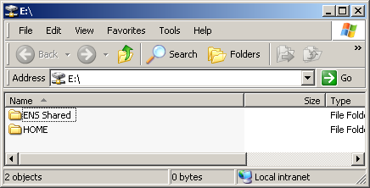

Remember, once you disconnect the VPN, this share will no longer be available.

Printers: You can also connect to a printer via the VPN connection much like the file share. Follow the directions for mapping a network drive using these changes:

- Substitute \\File\ with \\Print
- Right mouse click on the printer you wish to connect to and select Connect…
- When prompted, enter you network login (eohsi\<your login>) and password
- To verify the connection, go to Start Button→Settings→Printers and Faxes

